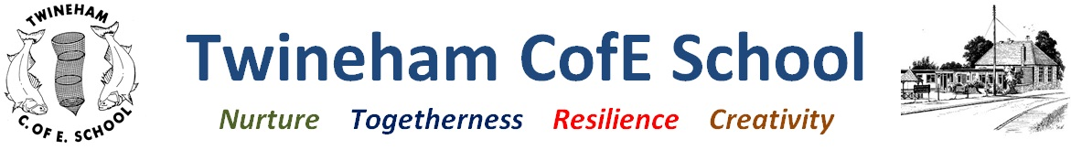
Our Curriculum: Autumn 2023

Outcomes | Texts | Key vocabulary | Curriculum intent
To be weather watchers and create weather reports.  To ask questions in science and conduct experiments to find the answers.  To compare apple farming locally with cocoa farming in Nigeria.  To plan and cook an apple crumble, evaluating the use of different spices for flavour  To develop colour mixing skills and study the work of Romare Bearden and Paul Cézanne | It Might Be an Apple  Lunch at 10 Pomegranate Street  The Farm that Feeds Us  The Secret Sky Garden | Harvest, farmer, agriculture, seasons, autumn, life cycle, seeds, spices, peel, core, slice, crumble, vanilla, cinnamon, nutmeg, ginger, recipe, instructions, imperative verbs, equipment, method, evaluation, Nigeria, Africa, local, Sussex, near, far, weather, rain, sun, wind, hail, weather fronts, forecast, high pressure, low pressure, north, south, east, west, continents, oceans  (Bold words to be taught through Sounds Write Lessons) | To understand that some food can be grown here, but other food comes from far away.  To understand that some food is seasonal.  To learn about and compare a farming community in a different place.  To consider the effect of climate change on farming communities learn how countries and people can help.
Narrative hook | Years 1 and 2: Poppy Class  (Autumn 2023) |  | Our School Values
It might Be an Apple – study real life apples  Poppy Class Pizza Parlour role play area. | Inquiry Question: Where does our Food Come From?  Concept: When we look after nature, nature looks after us. |  | Nurture: growing plants  Togetherness: Learning about farming communities here and in Nigeria  Resilience: cooking skills and trying new flavours  Creativity: cooking, art skills, colour work
Credibility: what will we learn? | Creativity: how will we show our understanding in multiple ways? | Coherence: connections to past and future learning | Compassion: empathy and understanding | Community: local, national and global links
How plants grow from seeds and bulbs;  How seasonal weather changes affect the things we can grow;  To name continents, oceans, countries and capital cities;  To compare farming here to farming in Nigeria;  How to make an apple crumble;  To evaluate how spices can change the flavour of food;  To mix colour and create artwork reflecting different places in the world | Weather presentations;  Cookery;  Map skills;  Artwork;  Comparative explanations | Y1: building on topic work How do we look after things?  building on farm visit: this time looking at farming for a specific crop  Y2: What makes a hero? Building on atlas and map skills – creating maps with more detail, using the eight points of the compass, deepening recall of continents, oceans, countries and capital cities.  Do we value what we’ve got?  Building on Wastebusters work to continue to look for solutions for global problems, | Looking after our local environment;  To look after seeds to help them grow;  To understand how other places are different to our place and consider the challenges different communities may face. | Dominos Pizza to supply products for our role play area  Links to community support from local supermarkets

