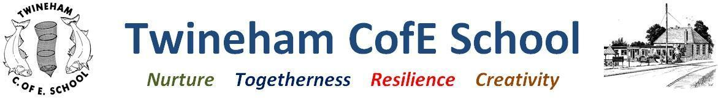
Our Curriculum of Hope
Outcomes | Texts | Key vocabulary | Curriculum intent
-Know and follow the routines of the school day.  -Build relationships with familiar adults.  -Be able to name and recognise feelings linked to the Colour Monsters.  -Take part in the Harvest Festival and the  Christmas performance | Orchard Book of Nursery Rhymes  Colour & Me  Funny bones  The Colour Monster  Little Owl & The Christmas Star | Body parts  Family and school names  Rhymes  Festivals (Harvest, Christmas) | We will be finding out about ourselves and each other, settling into school and working together as a class.
Year R: Buttercup Class (Autumn 2023) |  | Our School Values
Inquiry Question:  Why is it good to be me?  Concept: Ourselves |  | Nurture: Looking after ourselves  Togetherness: Agreeing shared rules and routines. Finding out about our similarities and differences  Resilience: Having a go at new things and working in new ways  Creativity: Sharing our learning, expressing and representing ourselves.
Credibility: what will we learn? | Creativity: how will we show our understanding in multiple ways? | Coherence: connections to past and future learning | Compassion: empathy and understanding | Community: local, national and global links
Literacy: exploring, reciting and innovating with rhymes. Becoming familiar with key stories.  Maths: Sorting and matching, comparing, Numbers to 5, name 2D shapes  Understanding the world: Our bodies and our families, people and places in school.  Expressive Arts & Design: Exploring paint and colour, representing ourselves & our families, joining in with songs and rhymes.  Communication and language: join in with familiar songs and follow instructions.  Personal social and emotional development: develop a sense of responsibly and membership of our school community. Talk about their own feelings and the feelings of others.  Physical development: using our equipment safely, developing gross and fine motor skills. | Through play outside and inside everyday!  In nature, with daily time on the field  Reciting, singing and enacting poems  Performing at Christmas and Harvest Festival  Through making marks with a range of materials  In our ‘Floor Books’ to share our learning. | Settling into school and learning school expectations.  Making links to their interests at home & nursery  Using familiar nursery rhymes.  Talking about themselves and their families  Looking after themselves - healthy eating, hygiene and self-care | Getting to know each other and why we have rules and routines.  Looking after ourselves and being healthy.  Identifying our similarities and celebrating our differences  Understanding our feelings and emotions. Recognising the feelings and emotions of other people. | Sharing learning with parents through Seesaw & Christmas show  Visiting our church.  Finding out about our families and important people at our school.  Knowing about festivals that we may or may not celebrate at home.

